Eustathios Spider V2 assembly manual

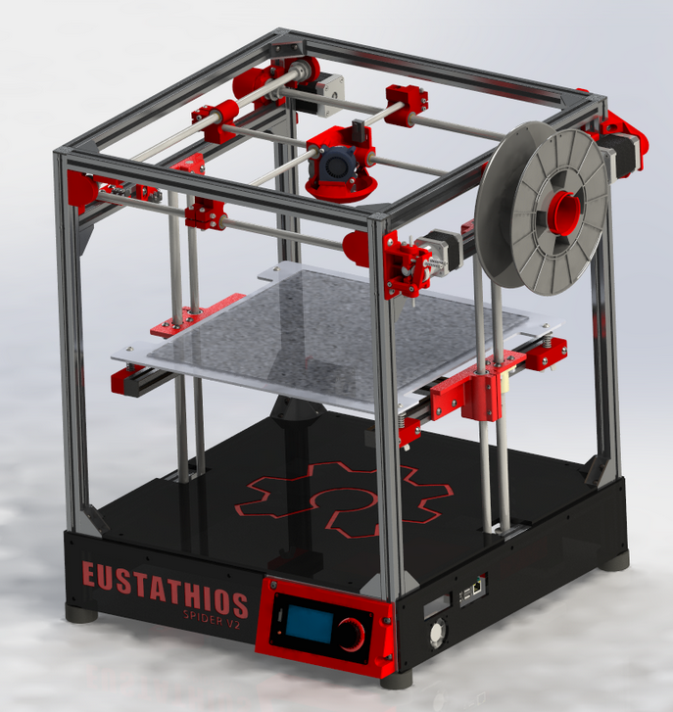

Revision 1.0 By Igor Kolesnyk

## List of content